London 2012

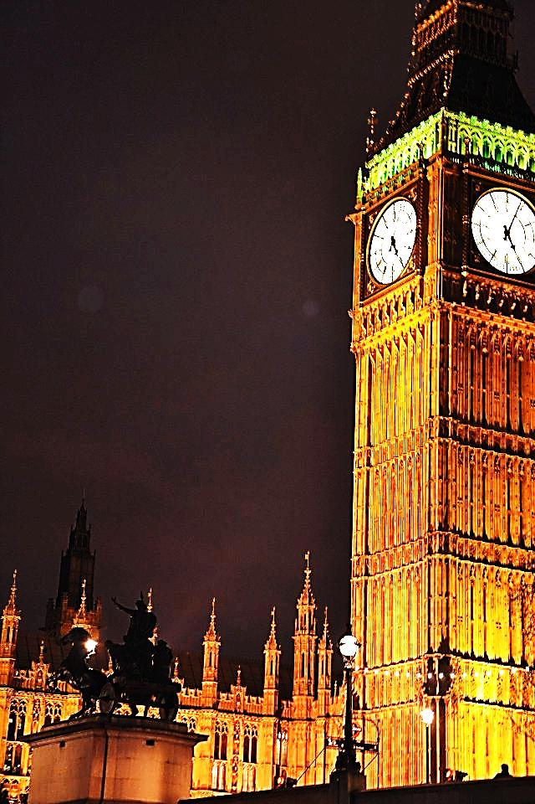

January 10 to January 12, 2012

3ème A & 3ème E
♥

Tuesday:
- In the morning
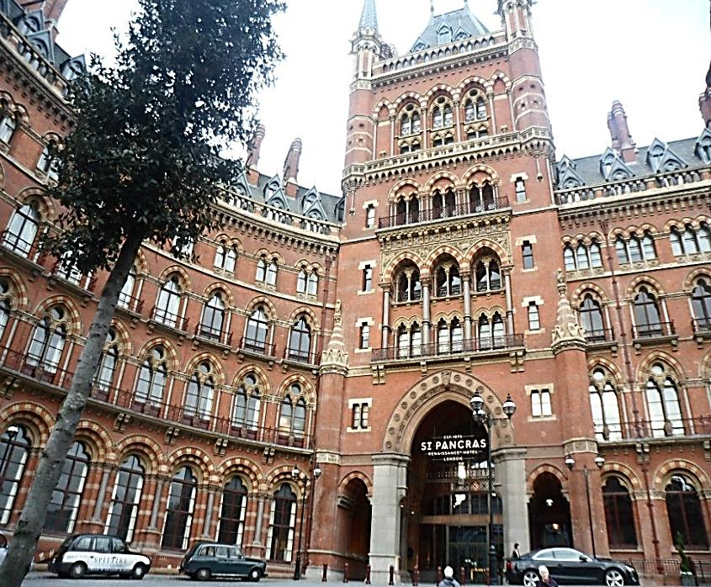
We gathered, early in the morning around 6:15 am at the underground station of my town. Then we went to Gare du Nord station and we took the Eurostar. After three hours we arrived in London at St. Pancras Station and we took the famous British “red bus”. Then we walked, we saw people dressed up and making show and we all took pictures with them. Then we decided to eat in Covent Garden and to make purchases over there.
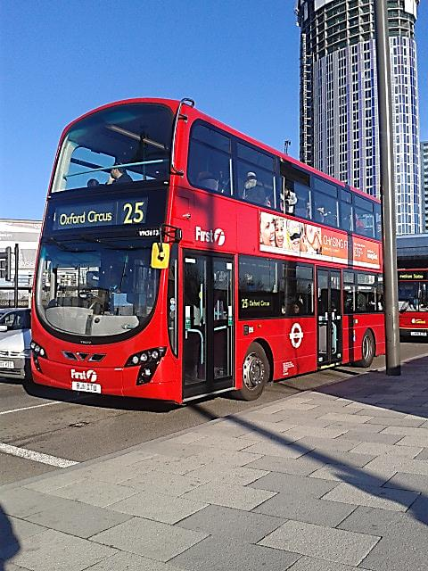
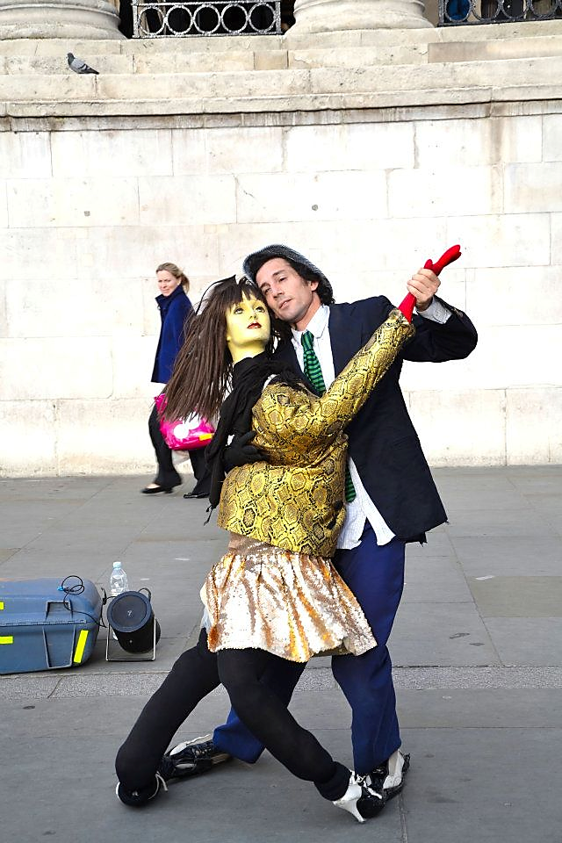

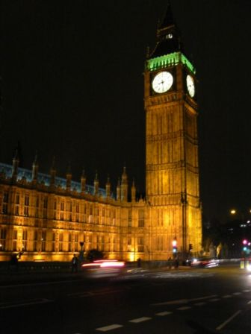
In the afternoon:

We took the tube in order to visit the emblematic Wembley Stadium. A man showed us the changing rooms of football players and we were allowed to enter the field. This man also explained to us that Wembley Stadium was the only one in Europe which can protect the spectators from bad weather. Wembley Stadium was renovated some months ago, it has 90,000 seats. This is the second largest stadium in Europe. Finally, we took a picture with a cup worthing, 75 000 pounds. I will never forget this fantastic visit.

After that we went to Westminster by tube for a ride in a barge on the Thames. We saw the famous Big Ben; it was wonderful.
The weather was cloudy but it didn’t rain. We were lucky because it was not cold. Finally we arrived happy but exhausted at the youth hostel which was next to Canada Water station

For the dinner we ate an Italian meal, I mean spaghetti Bolognese. We were six people per room. The beds were quite comfortable. We went to bed every day around 10:00 p.m. All my friends and I were tired because we walked all the day long and that was the reason why we slept very well.

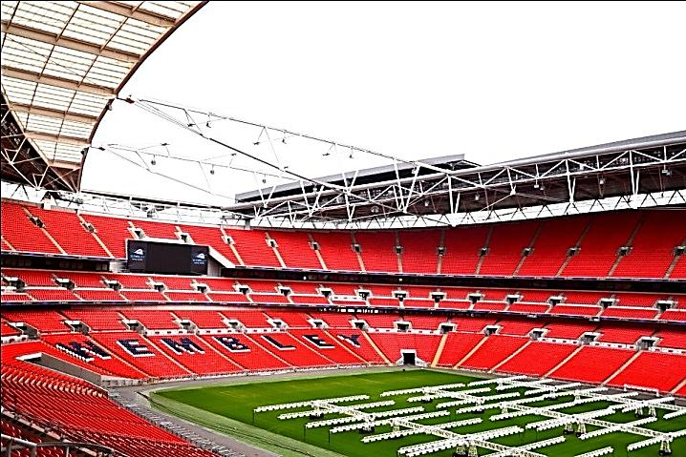
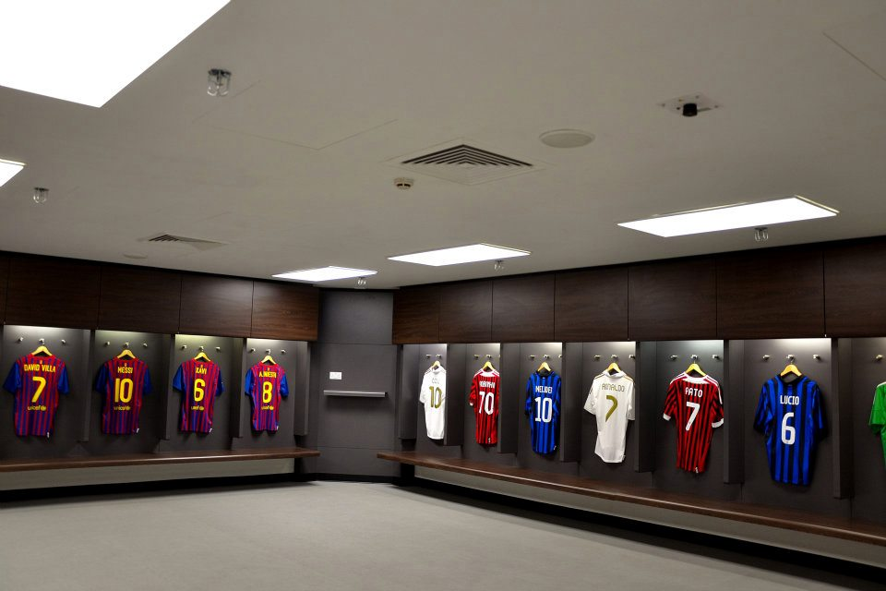
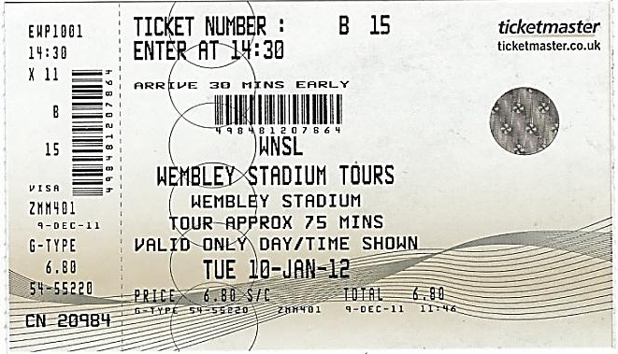
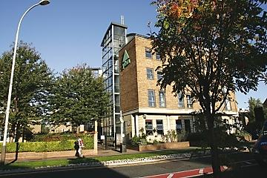
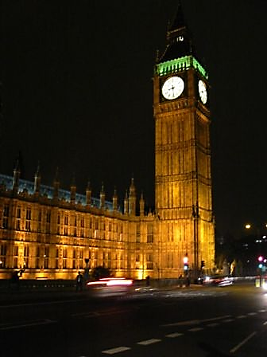
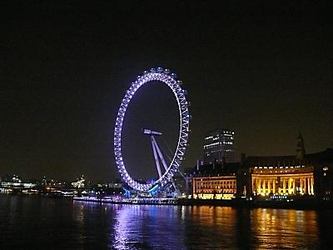
Wednesday:
- In the morning
We woke up at 7:30. For breakfast, we found a large choice of typical British products such as: sausages, bacon, potatoes, toasts... I had bread with butter, bacon and orange juice. Before leaving, the youth hostel gave us a meal for lunch. We took the tube for a visit around the Olympic stadium. A woman guided us during the visit. She explained everything to us. The Olympic Stadium will be the heart of the London Olympics. All Athletics events will take place in the Stadium as well as the opening and the closing ceremonies, watched by millions of people around the world. It will seat 80 000 people during the games.
After this visit we took the tube again in the direction of Green Park. The weather was sunny. We ate outside in the park because the weather was sunny and mild; Green Park is a beautiful and a big park.
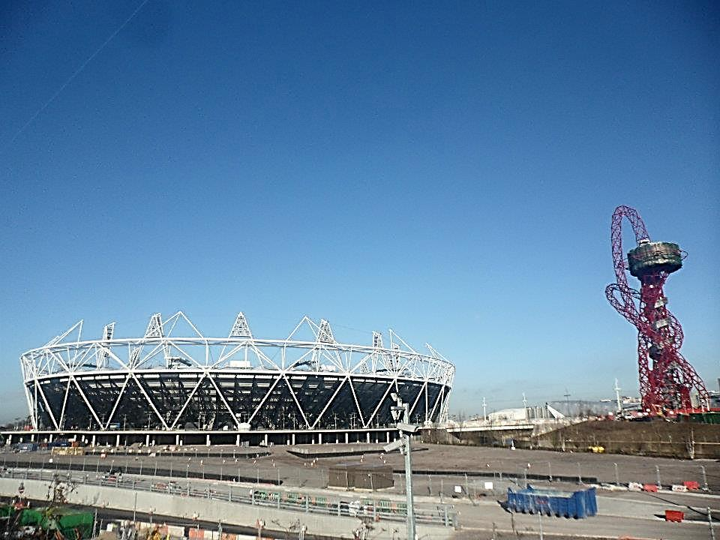
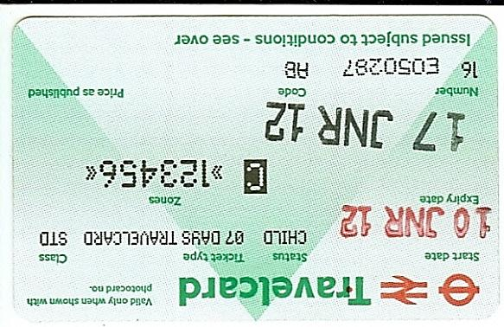

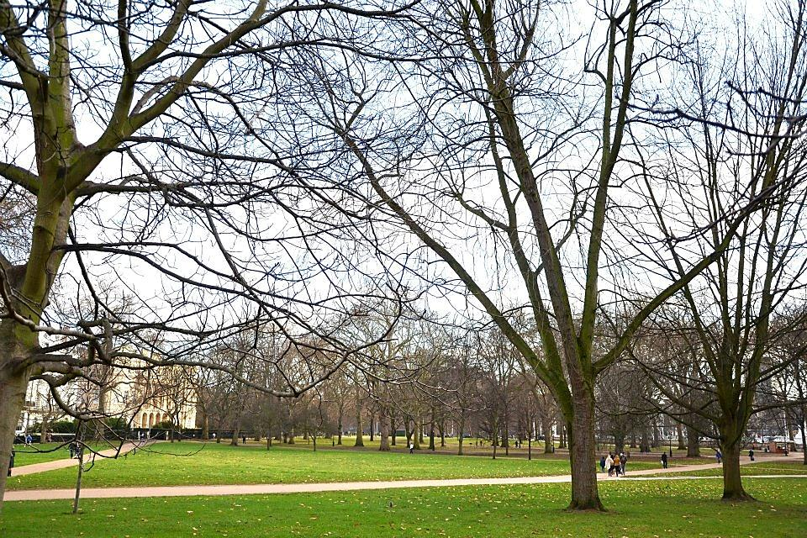

- In the Afternoon
We were redirected towards the metro to reach James Wood station. At that place, we played cricket. Two people were present to teach us how to play. There is a batter, a bowler and defenders.
Then we walked along a river for about an hour. We saw beautiful houses, very large and sumptuous. We arrived at Camden Market; this is where we did some shopping. Finally we used the tube to go to the youth hostel. The sky was overcast.
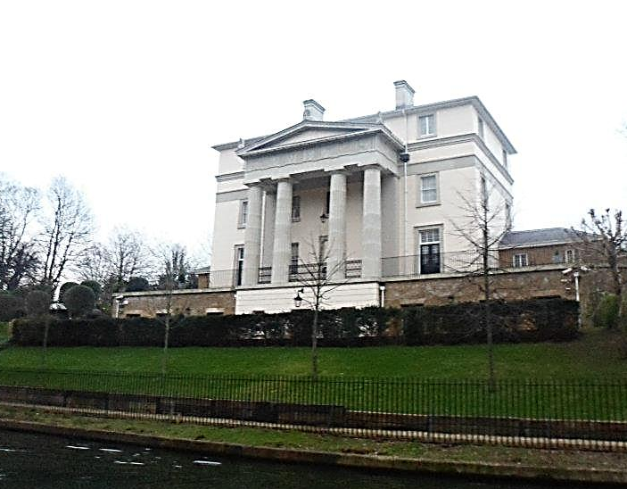
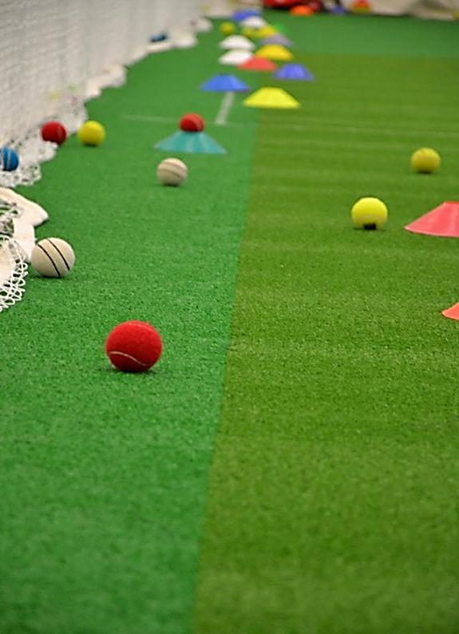
In the evening we ate a sausage with mashed potatoes. After showering, we watched TV and after that we went to bed around 10:15 p.m. We putted away our clothes in order to leave in the morning

Thursday:
- In the morning
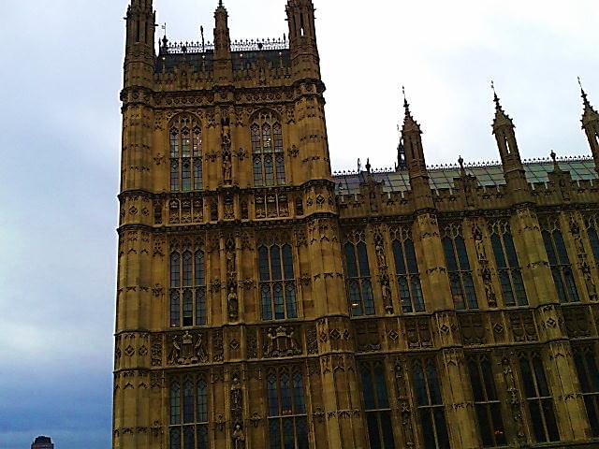
We got up at 7:15 am. After putting away our clothes, we took our breakfast. I ate the same thing as yesterday because I liked it. We left the youth hostel at 9:00 am. The youth hostel gave us a picnic for the trip in the evening. We took the tube to Westminster station. We saw the House of Parliament. Inside there was the Chamber of Deputies and Lords, and a guard. Then we walked in a park, we caught a glimpse of many squirrels and ducks. We saw the famous Buckingham palace and the Changing of the Guard. We used the tube to get to the restaurant the Marlborough Head. We ate fish and chips. It was good. The weather was still cloudy.
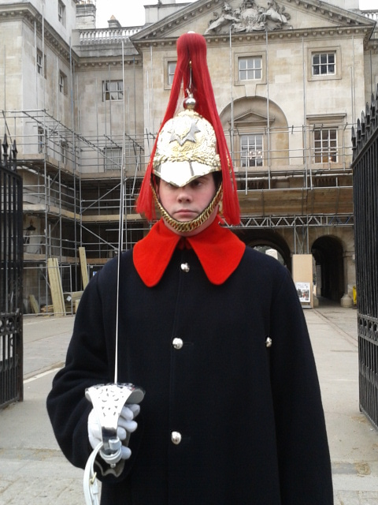

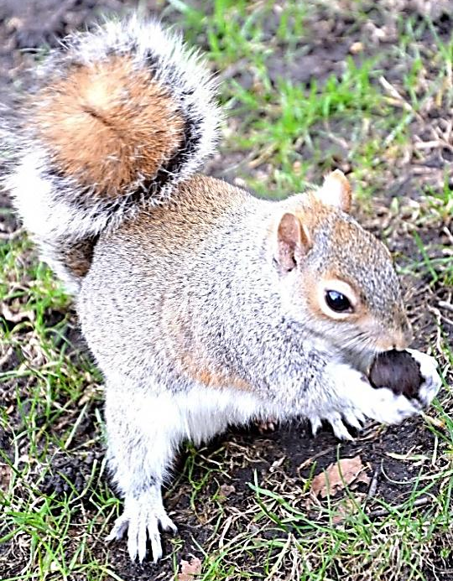
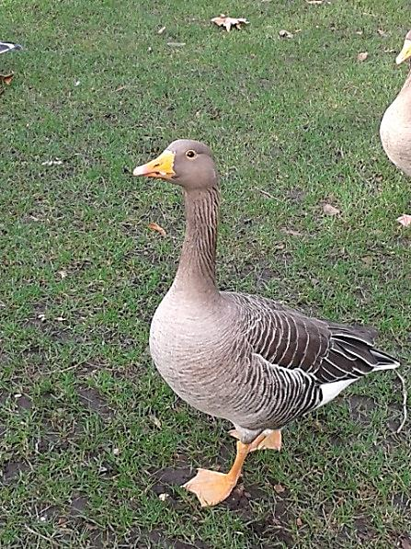

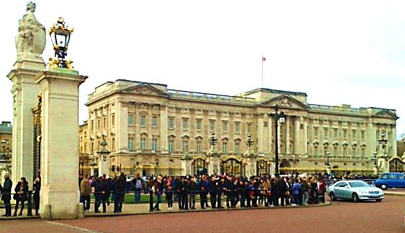
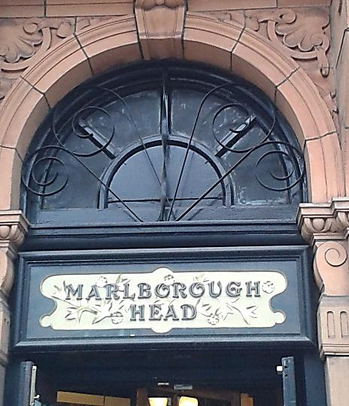
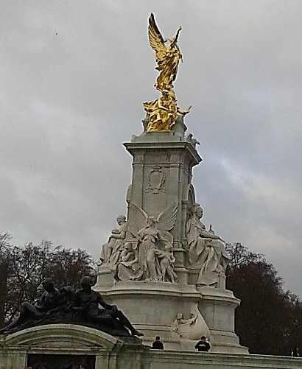
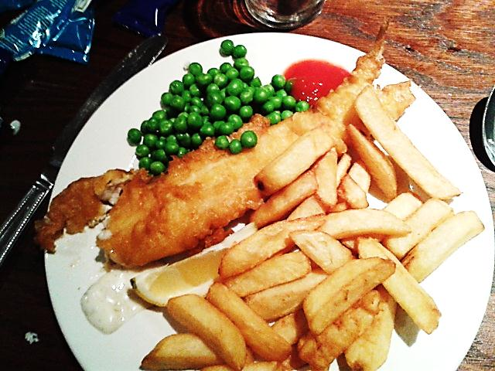

- The afternoon
We visited the Imperial War Museum concerning the Second World War; we saw planes and tanks. We entered reconstituted a trench ​​. We attended a simulated bombing. We saw pictures of concentration camps, Jews… We also saw soldiers uniforms. It was very interesting.
We took the tube in order to go to St.Pancras Station. We had some free time in the station. We bought some souvenirs for our families. Finally, we took the Eurostar at 10:00 pm. We ate on board.
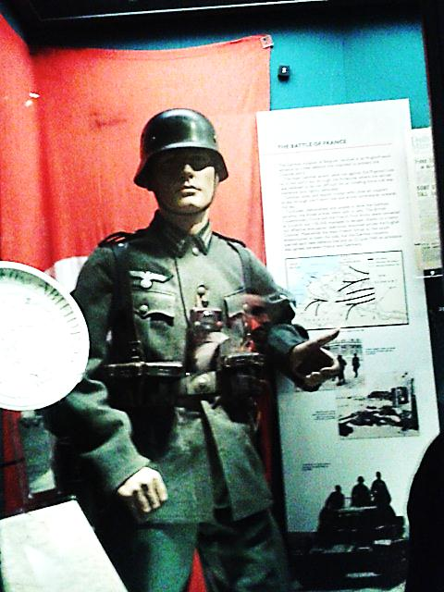
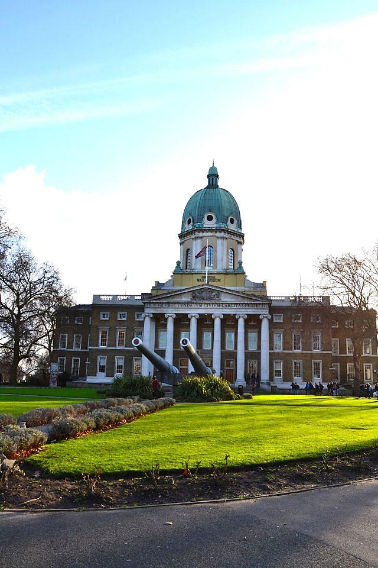
We arrived at the Gare du Nord at 11:00 pm. We took about an hour to go to the station of Houilles.

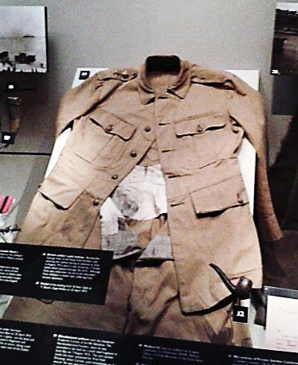

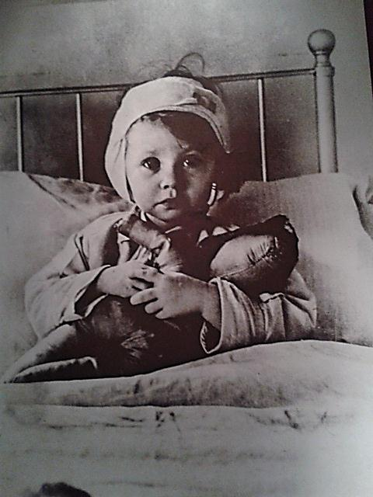

It was a wonderful trip!
I will never forget it!

Thank you so much Mrs. Lardenois, Mrs. Mallamaci, Mr.Barbier & Fayçal.

I love London

♥

